**Pymaceuticals Observations**

Objective:

To analyze the data to show how four treatments (Capomulin, Infubinol, Ketapril, and Placebo) compare. The study constituted 250 mice which were subjected to variety of drug regime and their physiological responses were monitored over 45 days period.

Observation 1:

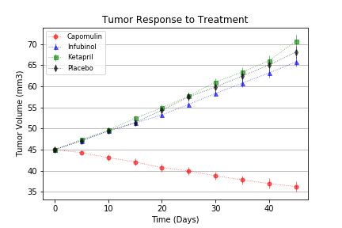

Mice treated with Capomulin experienced a reduction in tumor size over 45 days period. Tumor volume decreased approx. 19.48% on an average by the end of the study period.

Observation 2:

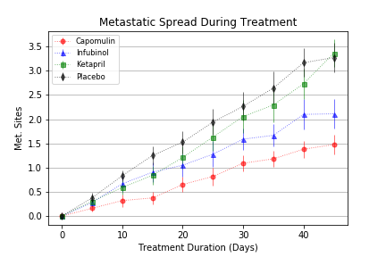

Mice treated with Capomulin showed the best results in slowing down the metastatic spread of the tumor comparing to other three methods as shown above in the graph. Placebo method showed the worst result of 3.3 among all other drugs, while Capomulin was at 1.5.

Observation 3:

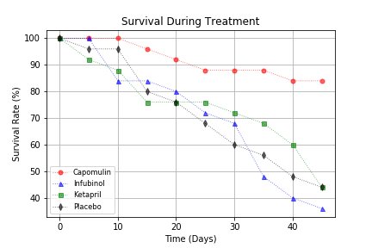

Mice treated with Capomulin showed the highest mortality rate of approx. 85% , comparing to the placebo method which showed mortality rate of approx. 46%.

Conclusion:

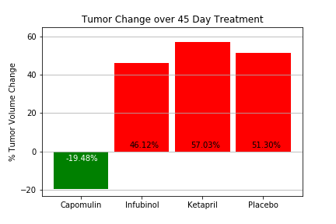

Out of the four treatments, Capomulin showed the best results in decreasing tumor size, stopping the spread of metastatic sites, and better mortality rate. Hence more research should be done on Capomulin and other drugs which showed better results than Infubinol, Ketapril, and Placebo.